Low-Temperature Printing of Silver Nanoparticle based Metal Grids for Photovoltaic Device Applications

Prepared by:
Louis J. Kjerstad

Faculty Advisors:
Dr. Michael K. West
REU Site Director, Department of Materials and Metallurgical Engineering

Dr. Jon J. Kellar
REU Co-Site Director, Department Head, Department of Materials and Metallurgical Engineering

Dr. Alfred R. Boysen
Professor, Department of Humanities

Program Information:
National Science Foundation
Grant NSF # DMR-0852057

Research Experience for Undergraduates
Summer 2011

South Dakota School of Mines and Technology
501 East Saint Joseph Street
Rapid City, SD 57701

Table of Contents

Abstract ………………………..….………….…………………………….…………….……… 3

- Introduction…….………………….……………….……………….……………………. 4

- Broader Impact …………….….……….………..….………….….…….….……………. 5

- Procedure …….…....……………..….…….……..……….………….…….….………… 5

  - Materials ……………….…………….…….…..……….………….…….………… 5
  - Equipment ………………………….…………..….….…….……………………… 6
  - Synthesis of silver nanoparticles and ink .….….….………………….….….……… 6
  - M³D aerosol jet printing and sintering ………………………………………….….. 7
  - Testing and analysis ….……….…………….………………….…………….…….. 9

- Results …………………………………….…………….…………..….………………. 10

- Discussion …………………………………………….…….…….…….……………… 13

- Conclusion ……………………………….………….…………………………………. 14

  - Future work ………….…………………………….….…………….……….……. 15

- References …………………………………………………….…….……….….……… 16

- Acknowledgments ……………………………………………………………………… 16

Abstract

Metal grids are critical for effectively collecting photon-generated charge carriers in photovoltaic devices. A few essential requirements for the metal grids include (1) narrow lines that enable large active area without compromising fill factor; (2) low process temperatures that are compatible with solar cells; (3) high conductivity that minimizes resistive loss; (4) efficient and low-cost processes that are suitable for large area module applications.^{[1]}
This study details research utilizing OPTOMEC’s Maskless Mesoscale Materials Deposition (M³D) aerosol jet printing technology for fabricating metal grids at low temperatures. The metal grids are composed of silver nanoparticles measuring 4 to 7 nm in diameter that were synthesized using decanoic acid as a capping agent. Microscope images and laser profilometry indicate the grids can be controlled within 45 to 85 μm width and within 1.5 to 7 μm thickness. Sintering temperatures ranging from 160°C to 220°C for a time period lasting 20 to 90 minutes were evaluated.
This paper entails the functional properties of this printing technology and the results produced. The synthesis of the ink is also discussed. In addition, the parameters that have the greatest impact on the printed grids are analyzed.

- Introduction

Metal grids are critical for effectively collecting photon-generated charge carriers in photovoltaic devices. This research demonstrates how controlled low-temperature and high speed printing as a form of direct writing technology can yield desirable results. Effective requirements for the metal grids in this application include narrow lines that enable large active area on the photovoltaic without compromising fill factor, low process temperatures that are amenable for photovoltaic devices, high conductivity, and efficient low-cost processes.
OPTOMEC’s Maskless Mesoscale Materials Deposition (M³D) aerosol jet printing is a technology suited for such tasks. As an excellent alternative to the heavy chemical use, etching, and clean room required in lithography, M³D aerosol jet printing is non-contact and is performed quickly and efficiently in a room environment. Line width results may typically measure from 5 µm to 5 mm. M³D aerosol jet printing produces a dense aerosol of microdroplets in a tightly focused, continuous gas stream that exits the nozzle head from a variable stand-off of 1 to 5 mm. This technique produces “stable and concentrated dispersions of metallic nanoparticles” necessary for printed electronics.^{[2]} The printing can be performed at various speeds with controllable amounts of material flow and different nozzle sizes.
Dr. Qi Hua Fan, Associate Professor in the Department of Electrical Engineering and Computer Science at South Dakota State University, presented the need for electrode metal grids to be printed on Indium Tin Oxide (ITO) coated slides as ITO is the same surface material used in photovoltaic devices. The goals of this research were to make approximately 50 µm wide lines with thickness measurements near 1 µm having high conductivity, strong adhesion, and low sintering temperatures, around 160°C for 20 minutes.
The process begins with the synthesis of silver nanoparticles that are capped with decanoic acid. The silver nanoparticles are mixed with toluene to produce a functional ink solution. Upon completion of printing, the samples are sintered. The printed grids harden and become conductive during this process. The line length, line width, line thickness, conductivity, and adhesion of the printed grids are then analyzed.

- Broader Impact

This project has the potential to aid in improving the efficiency of solar cells. By providing information about the efficiency of a photovoltaic device, necessary design changes can be made. In turn, the application of the printed grids would assist in decreasing reliance on fossil fuels, increase dependence on renewable energy, and unlock methods for more efficient energy capture.
Moreover, compared to lithography, this task of low-temperature printing in a non-clean room environment does not require highly controlled temperatures, heavy chemical use, etching, detailed lab safety equipment, or a clean room. Instead, this operation is a relatively quick process to set up and perform. It is also relatively inexpensive and has little to no toxic chemical waste.

- Procedure

3.1. Materials
Chemicals used were silver nitrate (99.99%, Sigma Aldrich), n-butylamine (99.99%, Sigma Aldrich), sodiumborohydride (99.99%, Sigma Aldrich), decanoic acid (99.99%, Sigma Aldrich), toluene, acetone, methanol, and heavy mineral oil.

3.2. Equipment
The equipment utilized in this study were OPTOMEC’s M³D aerosol jet printer, Axio-Cam MRc5 microscope, Signatone 1160 Series 4-Point Probe Station, Keithley 2400 SourceMeter, Omegalux LMF-3550 oven, and Zeiss Supra 40VP Scanning Electron Microscope (SEM).
3.3. Synthesis of silver nanoparticles and ink^{[3]}
Silver nanoparticles for this study were synthesized using a modified version of Lee et al.’s method.^{[4]} The process begins by mixing silver nitrate (0.075 mol) in n-butylamine (14.83 mL). The mixing is achieved by a magnetic stirrer at 400 rpm. A mixture of the capping agent decanoic acid (0.464 mol) and toluene (22.5 mL) was added to the solution once the silver nitrate was completely dissolved in the n-butylamine. Sodiumborohydride (2.837 gram) was added to the solution as a reducing agent. Once the reducing agent was added, the solution turned dark brown. After refluxing the solution for sixty minutes, an acetone and methanol mixture was added to precipitate the particles from the solution. These particles were filtered using a glass funnel filter. The nanoparticles were 4-7 nanometers in diameter and had a spherical shape.
Once the silver nanoparticles were dry, they were mixed in toluene with equal weight percentage to toluene. The solution was vortex mixed for 30 minutes at 3000 rpm and sonicated for 30 minutes. This process was performed twice. After completion, the solution was centrifuged for 90 minutes at 6000 rpm to separate undissolved particles from saturation solution. The final silver weight percent in toluene was 58%.
Prior to printing, heavy mineral oil (100 µL) was added to 1 mL of the prepared ink so as to limit overspray. The mineral oil increased the viscosity and the surface tension of the ink, so upon deposition it would decrease the chance of overspray. After vigorously shaking the ink solution, it was ready for the printing process.
3.4. M³D aerosol jet printing and sintering
The print design was created using 3D computer-aided design software. The designed grid consisted of five lines with square shaped pads at each end of the line; the total area encompassing the grid measured 12 mm by 7.5 mm. Each line connecting the square pads measured approximately 4.5 mm and these lines were less than 2 mm apart from each other (see Figure 1). Two printed grids characteristic of all the prints are depicted in Figure 2. M³D aerosol jet printing was conducted on Kapton®, Indium Tin Oxide (ITO), and glass substrates. Each substrate was cleaned prior to use with acetone or methanol.
Numerous parameters are controllable during the M³D aerosol jet printing process. The nozzle sizes utilized in this study were 250 µm, 200 µm, and 150 µm. The temperature during printing was held constant at 30°C. The vial containing the prepared ink solution is submerged in a bath (see Figures 3 and 4). Voltage, set between 35 V and 40 V, is used to produce ultrasonic waves that bombard the ink vial. The ultrasonic waves have a high enough energy to atomize the ink solution into microdroplets. The atomizer amount was set at 20 cm³, 25 cm³, and 30 cm³ depending on nozzle size. After atomization, the droplets are entrained in a gas that flows to the nozzle (see Figures 3 and 5). Under these conditions the ink has gained a dense aerosol consistency. At the nozzle head, the sheath gas is introduced to prepare the material for deposition. The sheath gas, usually flowing at 50 cm³, forms the flow into a condensed stream with a controlled diameter. This prevents the material from making contact with the nozzle wall; thus, it prevents clogging of the nozzle and the formation of large droplets upon deposition.^{[5]} Furthermore, the nozzle head is not in contact with the substrate. For this research, the nozzle head was approximately 3 to 5 mm from the substrate. The sheath gas causes the material to exit the nozzle head at a high velocity in a continuous, focused stream, which upon deposition allows for the print to meet the target specifications (see Figures 3 and 6). All printed grids were produced with either one or two passes on the same grid. The prints were completed at the rates of 25 mm/sec, 50 mm/sec, and 75 mm/sec.
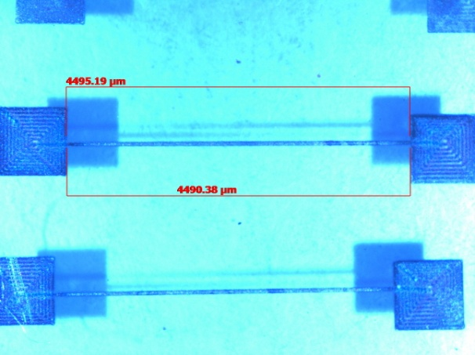
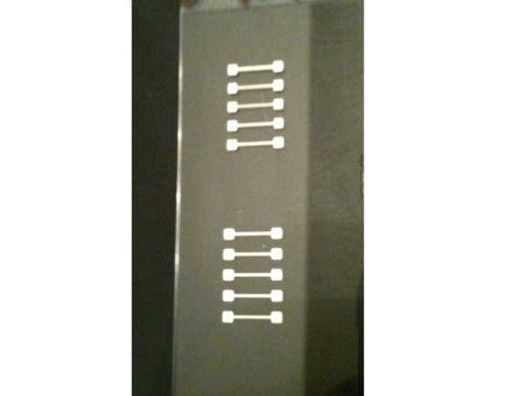
Upon completion of the printing, the printed samples were sintered in an Omegalux LMF-3550 oven. The sintering temperatures were controlled at 160°C, 180°C, 200°C, and 220°C for a time range of 20 to 90 minutes. These temperatures release the capping agent that was used to prevent the particles from coalescing while in the ink solution. After sintering, the grids become hardened and conductive.

Figure 2: Ag grid printed on glass;
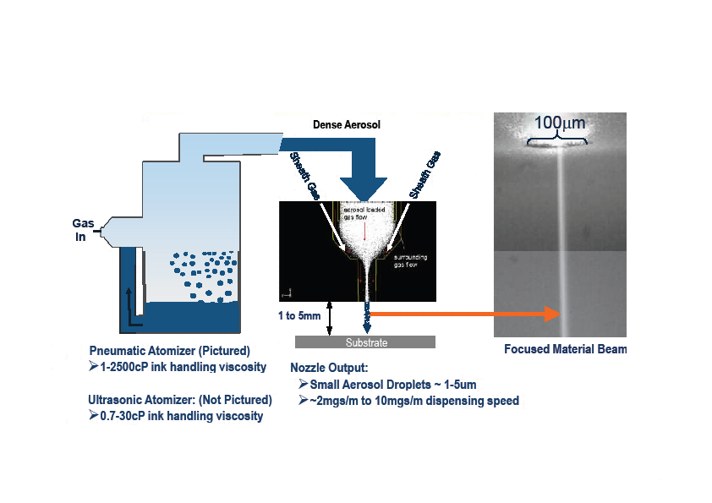
right print is 1-pass, left print is 2-pass

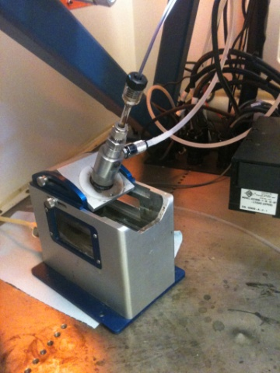
Figure 1: Ag grid printed on ITO

Figure 3^{[2]}: Schematic detailing the atomization and
printing of the M³D aerosol jet printing Figure 4: Bath where ultrasonic
process (modified image from source [2]) waves atomize the ink solution
Microdroplets entrained in gas form a dense aerosol consistency and flow through this tube to the nozzle head.
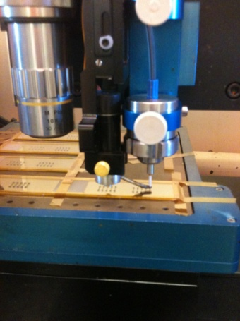
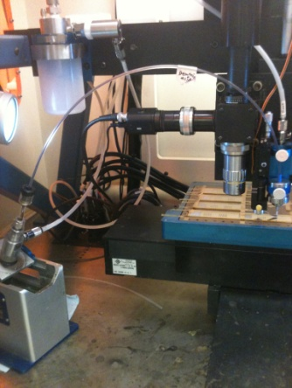

Nozzle head.

Figure 5: Flow of material after atomization Figure 6: Printing of Ag grids
to the nozzle head

3.5. Testing and analysis
Scientific instruments such as the Axio-Cam MRc5 microscope, Signatone 1160 Series 4-Point Probe Station, Keithley 2400 SourceMeter, and Zeiss Supra 40VP Scanning Electron Microscope (SEM) assisted in analyzing the samples. Conductivity was calculated using resistance, width, thickness, and length measurements (see Equation 1).^{[6]}
$$σ=\frac{L}{RA}$$
(1)

$σ$ = Conductivity measurement (Siemens)
L = Line length of print (meters)
R = Resistance measurement (ohms)
A = Area measurement (thickness X width)

Analysis began with the preliminary prints on Kapton® (see Figures 7 and 8). This produced standards for subsequent printing on ITO and glass. Initial line length and width measurements were estimated with the Axio-Cam MRc5 microscope (see Figures 1, 9, and 10). Accurate line width and thickness measurements were recorded with the SEM (see Figures 11-14). Samples were scribed and broken down the middle of the lines in order to measure thickness. The broken sample was then positioned in the SEM so the deposition protruded from the level surface of the substrate (see Figures 11-13). In addition, laser profilometry tests were conducted at South Dakota State University by Dr. Qi Hua Fan (see Figure 15). Adhesion was evaluated utilizing the 90° peel test by hand with Scotch® Clear Mailing Tape 141.^{[7]}

- Results
Preliminary prints on the substrate, Kapton®, provided results that influenced the succeeding prints. As displayed in Figures 7 and 8, multiple prints were conducted with an atomizer range from 25 to 45 cm³, sheath gas range from 50 to 70 cm³, and voltage range from 30 to 45 V. The sintering temperature and times were 160°C for 20 minutes and 180°C for 90 minutes. The nozzle size used for these prints was 250 µm. One and two pass prints were completed. The overall line width resulting from these prints (see Figure 9) ranged from 90 to 115 µm. One-pass prints grouped from 90 to 105 µm. Two-pass prints grouped from 100 to 115 µm. Thickness measurements were conducted with laser profilometry, but results varied too greatly, ranging from 0.5 to 6 µm to be considered accurate. Conductivity measurements of the prints sintered at 180°C for 90 minutes were calculated to 2% of bulk silver. However, this measurement may have been inaccurate as recording resistance measurements proved challenging. The conductivity measurements from the 160°C sintering temperature for 20 minutes proved very challenging due to the overall softness of the grids.

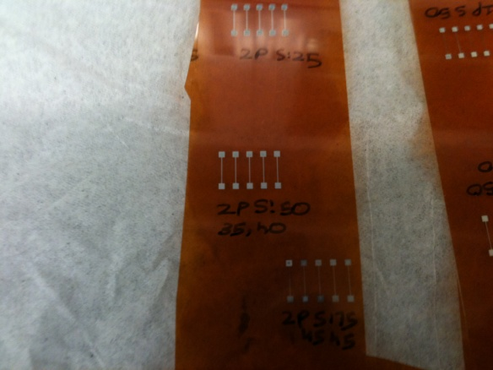
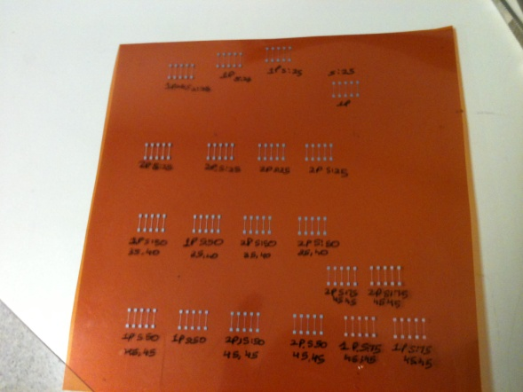

Figure 7: Ag grids printed on Kapton® Figure 8: Close view of Ag grid on Kapton®

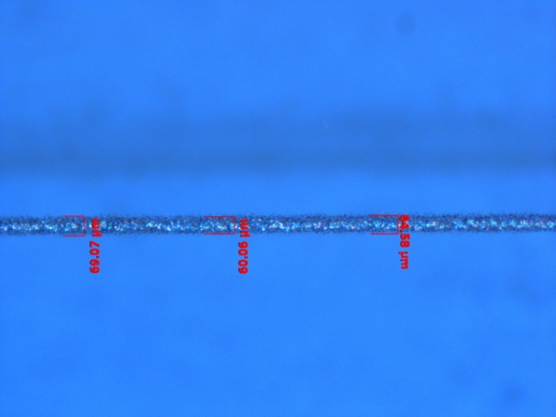
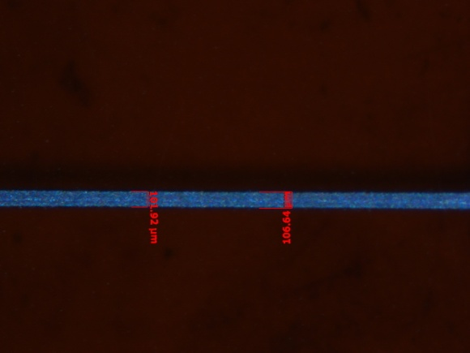

Figure 9: Line width measurement of 1-pass Figure 10: Ag grid printed on ITO;
Ag grid printed on Kapton® 1-pass line width measurement

After the preliminary printing on Kapton®, all printing was completed on ITO or glass substrates. The resulting line widths hovered between 55 to 85 µm. The one-pass prints had line width measurements grouped between 55 and 70 µm (see Figures 12 and 15), and the two-pass prints line width measurements grouped between 65 and 85 µm (see Figures 13-15). Thickness measurements ranged from 1.5 to 7 µm. One-pass prints measured between 1.5 and 3.5 µm (see Figures 11,12, and 15). Two-pass prints measured between 5 and 7 µm (see Figures 13 and 15). The sintering temperature was 160°C for 20 minutes. Adhesion testing was conducted by hand using the 90° peel test. The tape used was Scotch® Clear Mailing Tape 141. Based off adhesion strengths of similar tapes ranging 40 to 60 ounces per inch, this tape is estimated to have an adhesion strength likely in that range. Since a significant amount of the deposition appeared to remain after the test, this test indicated strong adhesion of the one-pass and two-pass printed grids to the ITO substrate (see Figures 16 and 17).

Figure 11: 1-pass print on ITO; thickness Figure 12: 1-pass print on ITO; length
measurement using SEM and thickness measurement using SEM

Figure 13: 2-pass print on ITO; width and Figure 14: 2-pass print on ITO; width
thickness measurement using SEM measurement using SEM

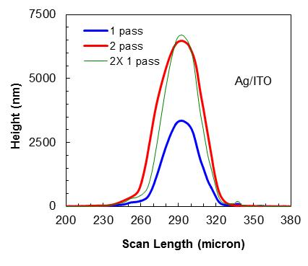
Figure 15^{[1]}: This figure depicts results from laser profilometry performed on 1-pass and 2-pass prints on ITO. The blue line indicates the height and width measurements recorded of the 1-pass print. The green line denotes the blue line/1-pass print results multiplied by 2. The red line is the actual measurements from a 2-pass print. These results indicate how predictable the printing results are.

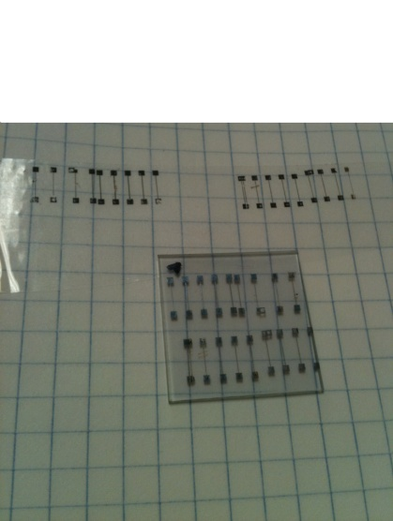
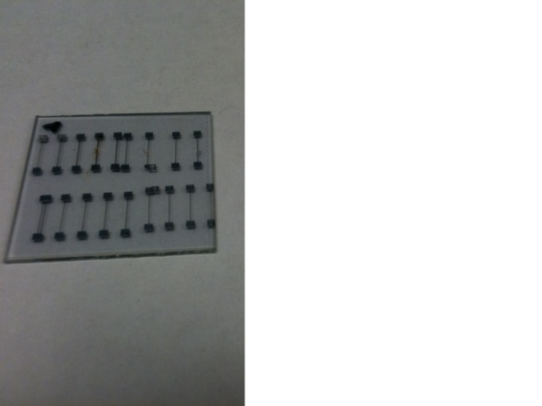

Figure 16: Ag printed grids on Figure 17: Grids displayed at top are what adhered
ITO prior to adhesion testing to the tape from the test. The sample below is what remained after the test.

- Discussion

Important parameters that proved to have a strong impact on the overall printed grids was nozzle size and sintering temperatures. The 150 µm nozzle provided results closest to the target specifications when printing under these parameters: voltage set at 35 V, atomizer rate at 30 cm³, sheath gas rate at 50 cm³, temperature at 30°C, and printing speed at 50 mm/sec. However, conductivity readings proved difficult to record for these prints. The lines appeared too soft for the 4-point probe to record any resistance measurements. Longer time periods and slightly higher temperatures for sintering may produce harder lines and more conductive lines. Samples sintered at 160°C, 180°C, 200°C, and 220°C for 90 minutes were still being analyzed at the end of this research. These are likely to produce evidence for that statement and further insight on sintering temperature and conductivity correlation.
Overall, the results of this research prove that M³D aerosol jet printing is a viable candidate for this type of photovoltaic application. When compared to lithography, printing efficiently in a room environment is an important precedent to be set. In addition, the process is completed in a short time period, allowing efficient production and analysis. Once further research on surface energy of the substrates, carboxylic capping agents in prepared inks, and sintering temperatures is conducted, this technology has the potential to sufficiently produce the necessary requirements for metal grids in photovoltaic device applications.

- Conclusion

Low-temperature printing is an inexpensive option that has the ability to yield viable results within this application. This study demonstrated how metal grids can be written without compromising the large active area on photovoltaic devices while achieving desirable results. It also displayed how controllable this form of direct write printing is from how controllable the results are to how efficient the process is. For instance, certain parameters produced features on the metal grids that were predicted and repeatable within microns. Moreover, the M³D aerosol jet printing process poses another advantage as it is an effective process, taking a small amount of time to complete.

7.1. Future work
Numerous recommendations can be made based off this study on how to proceed with further research. The following recommendations could potentially lead to more functional metal grids based off their impact in this research:
- Clean and prepare the substrates prior to use in various manners so as to control surface energy. These preparations would include plasma cleaning or silane surface functionalization. Analyze the samples to see how different preparation affected the features of the prints.
- Use prepared ink solutions with different carboxylic capping agents to test if the lower sintering temperatures work better for yielding higher conductivity and hardened lines.
- Conduct more thorough adhesion testing. Perform an actual peel test with a controlled force over an given amount of time. Test tapes with different adhesion strengths and examine how well the prints adhere to the tapes. Observe the samples under SEM prior to peel testing and after the peel test. Analyze the tapes under SEM after the peel test to potentially measure how much material is removed during test.
- Perform the sintering process multiple times. For instance, if sintering at 160°C for 20 minutes, repeat this process several times. This could decrease the overall softness of the lines and increase conductivity while remaining compatible to low temperature processing compatible for solar cells.
- Conduct more prints with varying parameters such as speed, atomizer, sheath, and nozzle size so as to optimize printing results. Utilize SEM to observe if overspray is more or less controlled under what parameters.

- References

[1] Fan, Qi Hua, Kellar, Jon J., Cross, William, Ankireddy, Krishnamraju, & Kjerstad, Louis. (2011). Low-temperature printing of silver nanoparticles based metal grids for photovoltaic device applications. Accepted for presentation at the Photovoltaic Materials and Manufacturing Issues II Workshop. MRS Technology Development Workshop Series. October 4-7, 2011. Denver, Colorado.
Figure 15 is credited to this source.

[2] Renn, Michael. (2008). M³D aerosol-jet-printing—5 microns to 5 millimeters. OPTOMEC professional presentation.
Figure 3 is credited to this source.

[3] Ankireddy, Krishnamraju, Vunnam, Swathi, Cross, William, & Kellar, Jon J. (2011). Short chain carboxylic acid(s) encapsulated silver nanoparticulate inks for direct write technology applications. Awaiting submission to Langmuir.

[4] Lee, Kwi Jong, Lee, Young-Il, Shim, In-Keun, Joung, Jaewoo, & Oh, Yong Soo. (2006). Direct synthesis and bonding origins of monolayer-protected silver nanocrystals from silver nitrate through in situ ligand exchange. Journal of Colloid and Interface Science, 304, 92-97.

[5] (2006). Aerosol jet is not inkjet. OPTOMEC.

[6] Rizzoni, Giorgio. (2007). Principles and applications of electrical engineering. Fifth Edition, pages 42-45. McGraw-Hill. New York, NY.

[7] Lacombe, Robert. (2006). Adhesion measurement methods: theory and practice. Taylor &Francis Group. Boca Raton, FL.

- Acknowledgments

The National Science Foundation funded this summer Research Experience for Undergraduates. Special thanks owed to advisor Dr. Jon Kellar for his insight and direction, Dr. William Cross for his guidance and ideas, South Dakota State University Associate Professor Dr. Qi Hua Fan for his initiation and supervision of the printing project, REU site director Dr. Michael West for his accommodations and support, communications advisor Dr. Alfred Boysen for his assessment in speaking and writing, Mr. Krishnamraju Ankireddy for his assistance and help, and Mr. James Randle for his instructional use of scientific equipment.

